Appendix A:
System Sequence Diagram

Appendix A: System Sequence Diagram
System Sequence Diagram:
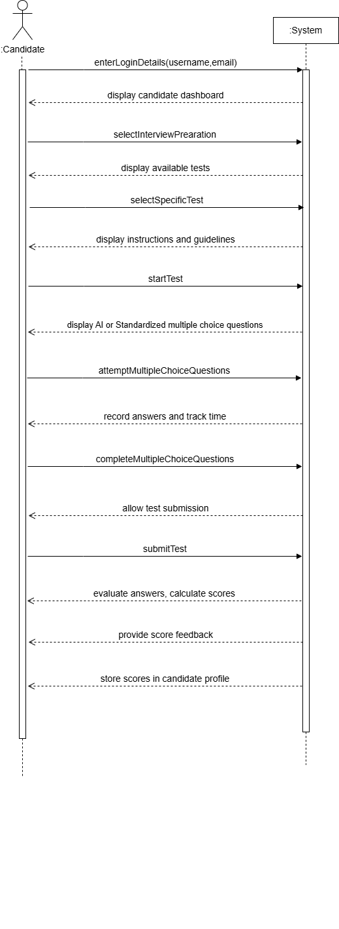
- Attempt Test
Figure 4.8 Attempt Test
- Attempt Technical test
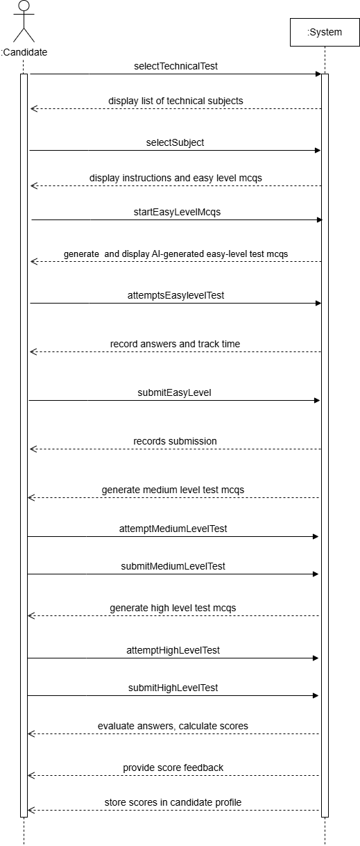

Figure 4.9 Attempt Technical Test

- Attempt IQ test
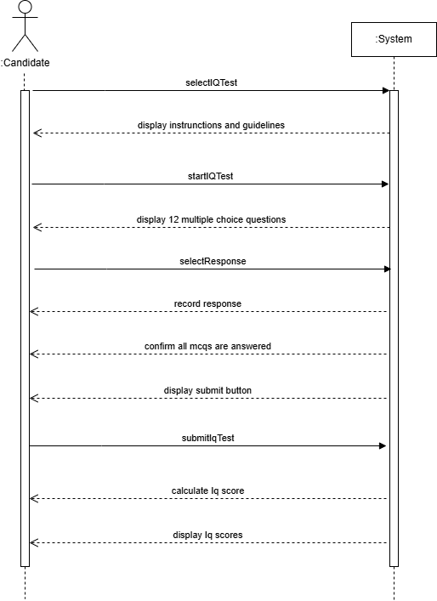

Figure 4.10 Attempt IQ Test

- Attempt EQ test
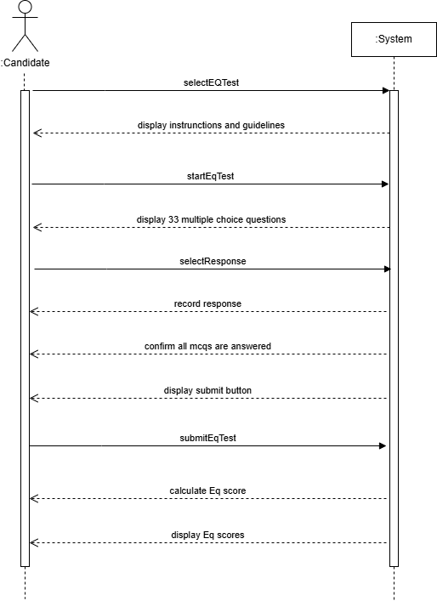

Figure 4.11 Attempt EQ Test

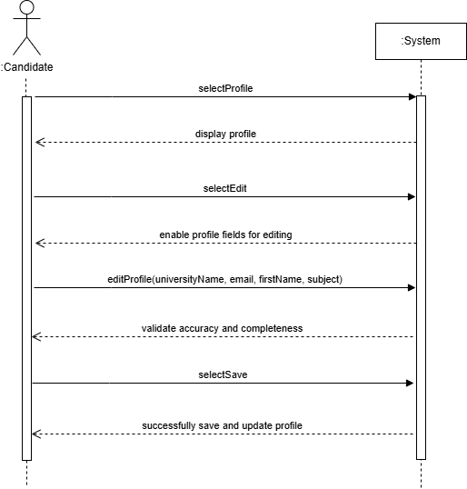
- Manage Profile

Figure 4.12 Manage Profile

- Manage Resume
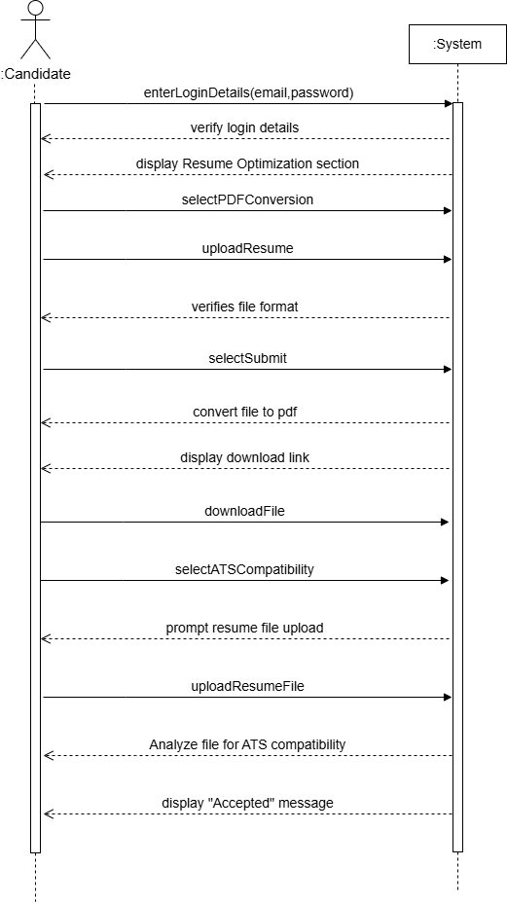

Figure 4.13 Manage Resume
- Login
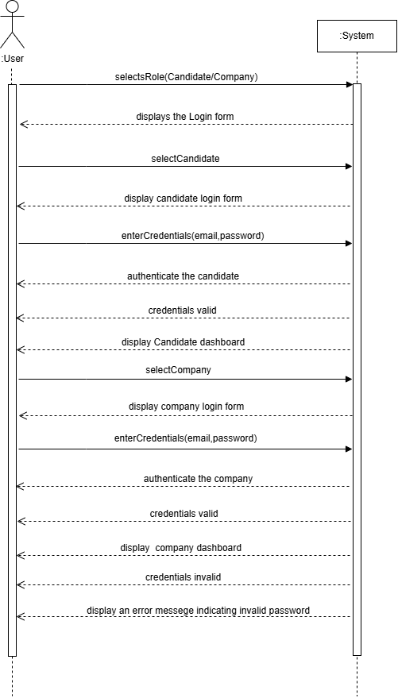
Figure 4.14 Login

- Signup
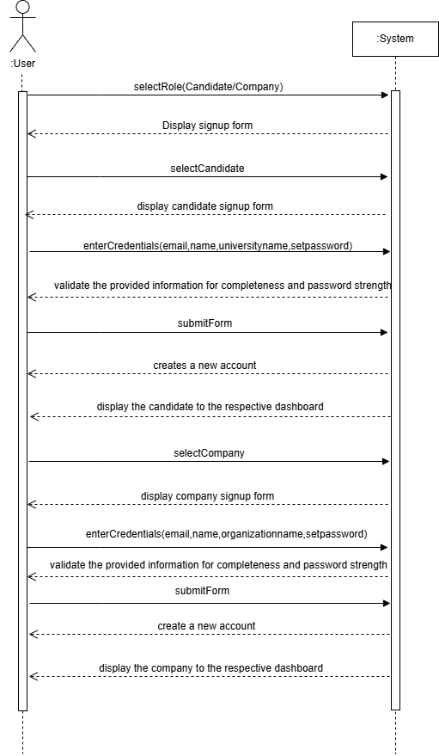
Figure 4.15 Signup

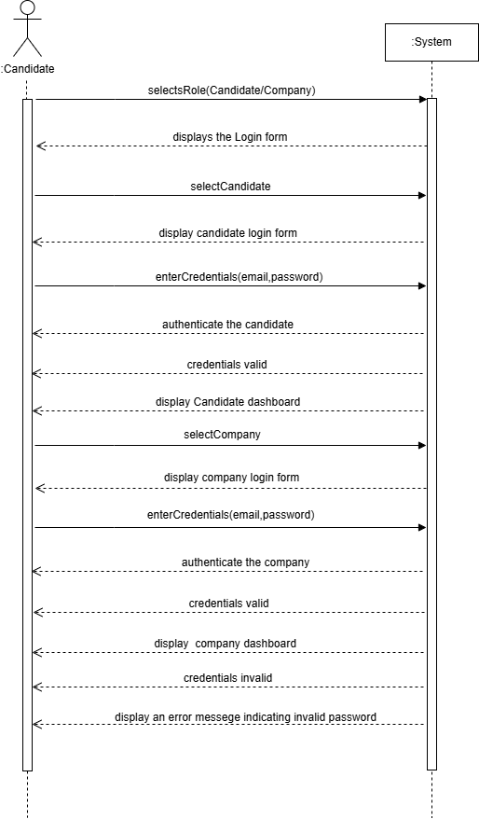
- Browse Candidate Profile

Figure 4.16 Browse Candidate Profile
- Browse University Analytics
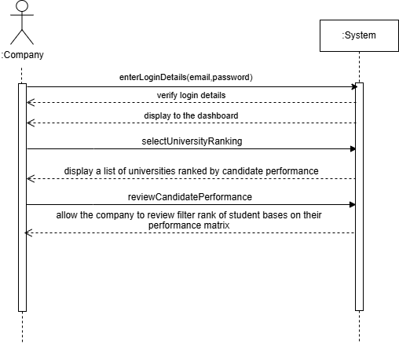
Figure 4.17 Browse University Analytics

- Question Vault
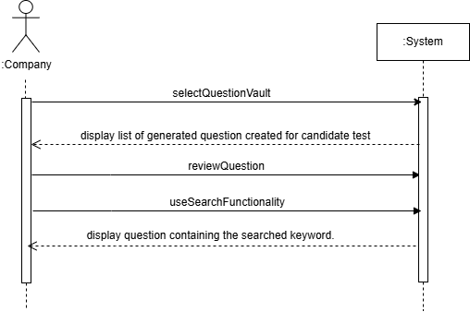
Figure 4.17 Question Vault

Figure 4.8 Signup

